Project Design Phase-II Customer/userjourneymap

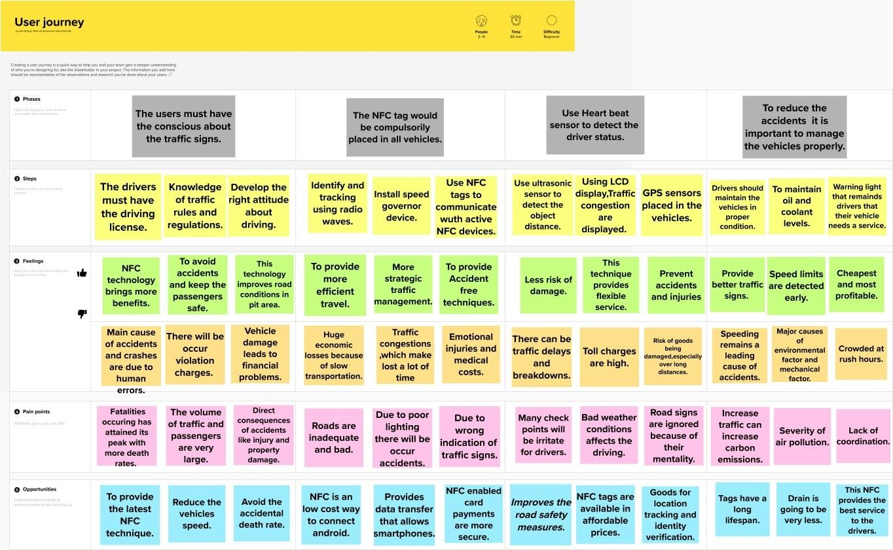Template: